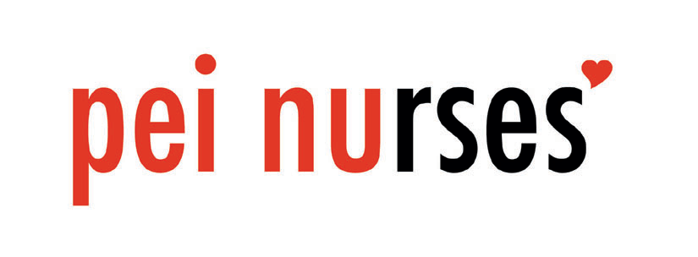
BOARD MEETING
June 8th and 9th, 2021
(CFNU Biennum 11-4pm)
9:00 a.m. to 11:00 p.m.
1. |  | Call to Order
2. |  | Roll Call
3. |  | Approval of Minutes – May 12, 2021
4. |  | Approval of Agenda
5. |  | 5.1 AGM Debrief  5.2 Review of Constitutional changes  5.3 Election 2021  5.4 Discussion re QEH and NP local  5.5 Presidency (Kim J)  5.6 Education Fund motion  5.7 Hot Topics- MRT, Paramedics in ED
8. |  | Reports  Local Reports – submitted electronically prior to the meeting.  *Highlights only.
9. |  | Date of Next Board Meeting - Sept 22, 2021  *** Reminder to notify office of any big issues over the summer. The Board will schedule a meeting August 4th in person or virtually if needed.
10. |  | Adjournment

